**FUNCTIONAL AND TECHNICAL COMBINED DOCUMENTATION**

**Page.tsx: First Home Page (Front End Url:** http://localhost:8100/page/page1)

**Functional Picture:**

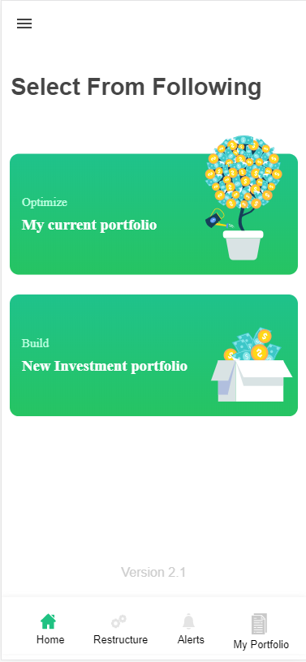

**Technical Explanation (Front End):**

**In Page.tsx:**

**This is simple html-ionic front end code. We are not calling Back End Api in this page. This has just plain and simple front end code. You can see the code in Page.tsx.**